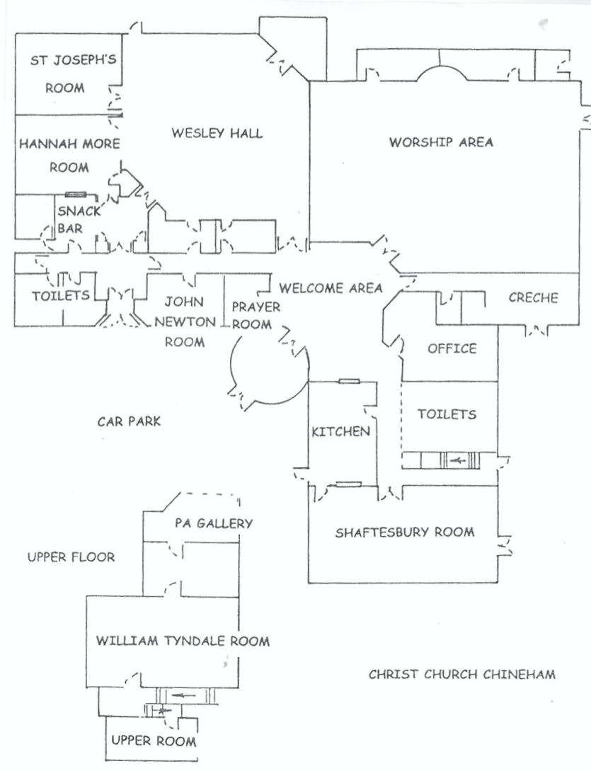
For further details or to book, please contact the
Parish Office on 01256 474280 or visit www.christchurchchineham.org.uk
[Revised 03-12-22]

ROOM HIRE
at Christ Church
for
children’s parties, meetings,
training events, evening classes,
orchestra rehearsals,
coffee mornings,
family celebrations,
special functions …

Reading Road, Chineham RG24 8LT
www.christchurchchineham.org.uk
Twitter: @ccChineham
Facebook / Instagram: christchurchchineham

We have a variety of rooms available for hire on a one-off or regular basis. Please see the plan on the back.
NB: all charges include hire of the large or small kitchen (whichever is the closest), and tea/coffee.
We have reduced rates for Christ Church members.
WESLEY HALL
Our large hall which holds 150+ people. Carpeted, it’s suitable for parties, exercise classes, and large meetings.
Commercial rate - £27.00 / hr
Community rate - £21.00 / hr
SHAFTESBURY ROOM
A large carpeted function room which easily holds 50 people. This room is suitable for adult parties, evening classes and so on. It has black-out blinds to help with presentations or films.
Commercial rate - £27.00 / hr
Community rate - £21.00 / hr
WILLIAM TYNDALE ROOM
This room is upstairs and is carpeted. It holds up to 20 people and is suitable for meetings, evening classes and so on.
Commercial rate - £17.20 / hr
Community rate - £13.25 / hr
HANNAH MORE ROOM
Suitable for groups of up to 20 people, this room has washable flooring, so is particularly suitable for children’s groups, small parties and any messy activities. There is a hatch from the small kitchen directly into the Hannah More Room.
Commercial rate - £14.00 / hr
Community rate - £10.80 / hr
ST JOSEPH’S ROOM
Suitable for smaller groups of up to 12 people, this room has washable flooring, and is particularly suitable for children’s groups, small parties and any messy activities.
This room doesn’t have its own entrance, so can only be hired in collaboration with the Wesley Hall.
Commercial rate - £12.40 / hr
Community rate - £9.50 / hr
UPPER ROOM
This room is upstairs and is carpeted. It holds 12+ people and is suitable for small groups.
Commercial rate - £12.40 / hr
Community rate - £9.50 / hr
JOHN NEWTON ROOM
A carpeted room on the ground floor suitable for small meetings of up to 10 people.
Commercial rate - £12.40 / hr
Community rate - £9.50 / hr

